Specifications
Software: | bOS PRO Comfort License, Included: 3 Users
Size: | 107 mm x 61 mm x 50 mm (WxHxD)
CPU | 1,2 GHz quad-core ARM
RAM | 1 GB
Disk: | SD card 32 GB
Connectors: | 1 x KNX, 4 x USB, 1 x Ethernet port
Power: | 110-240VAC 0.35A 50/60 Hz
OS: | Linux
Power consumption: | approx. 2 W
Product # | CC-J-1

Please check our support tools for more information on how to work with bOS: www.comfortclick.com/Support
- Always shut down Jigsaw properly by shutting it down in bOS Configurator. Don't shut down Jigsaw by unplugging it from the power supply.
- The use of UPS is recommended.

Jigsaw Quick Manual
- Installation - mount your Jigsaw on the DIN rail, connect the power supply, KNX and connect the Jigsaw to the network.
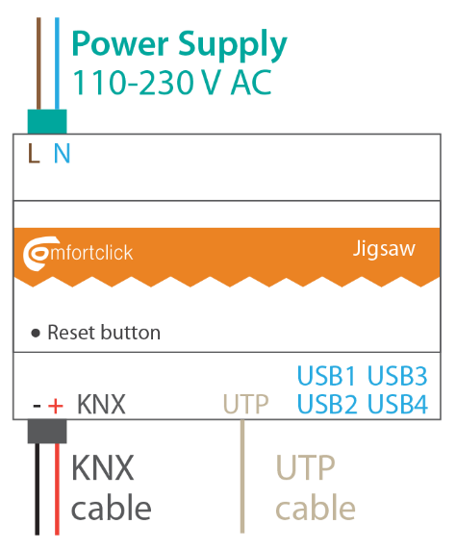
- Download and install bOS Configurator on your PC. You can get bOS Configurator on our web page: www.comfortclick.com/Software/Details/BOSConfig

- Connect to the Jigsaw
- Make sure that the PC with bOS Configurator is connected to the same network as your Jigsaw or Jigsaw is connected to the Internet and ports XXXX
- Open bOS Configurator
- Right click on the connection profile, then select Edit
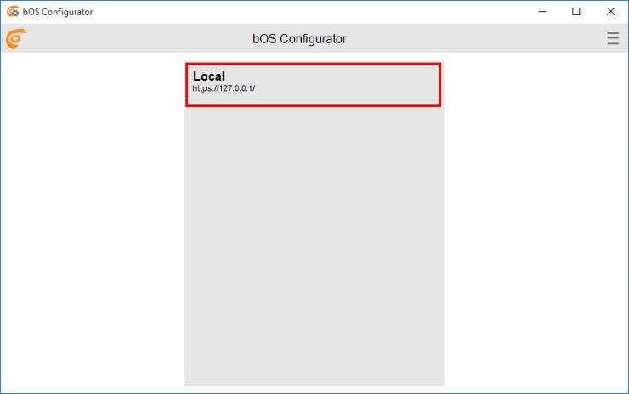
- Enter your Access ID, User name and Password

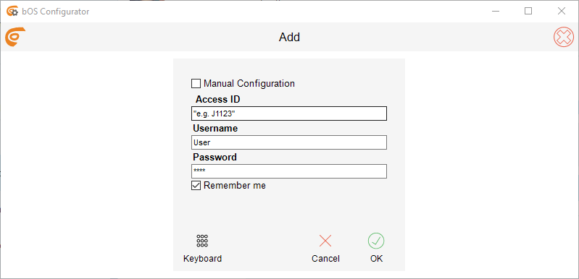
Enter your Access ID. By default, your Access ID is the serial number of your Jigsaw (without - ; e.g. J1123). You can see the serial number on the sticker on the bottom of your Jigsaw.
Access ID is a unique name for accessing the bOS Server. This name enables adding profile and accessing your bOS Server, without the need of knowing it's IP address.
Enter Username: User and Password: Pass and click OK

- Edit Jigsaw Access Settings
- If you like, you can change your access ID and other access settings.
- Open bOS Configurator
- Click Edit button
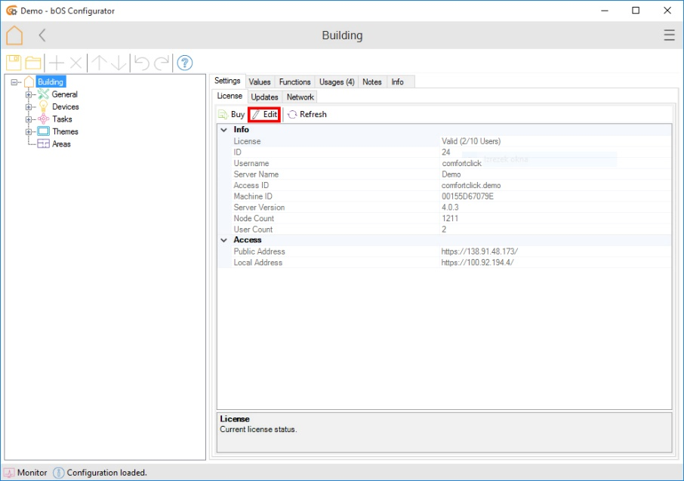

- Login to your account on our web page
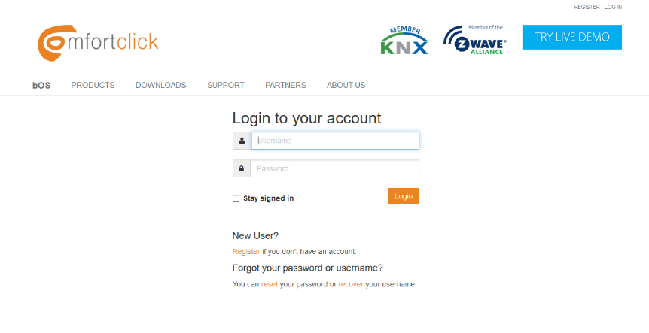
- You can now change your Server name, Access ID, Public Address and Local Address
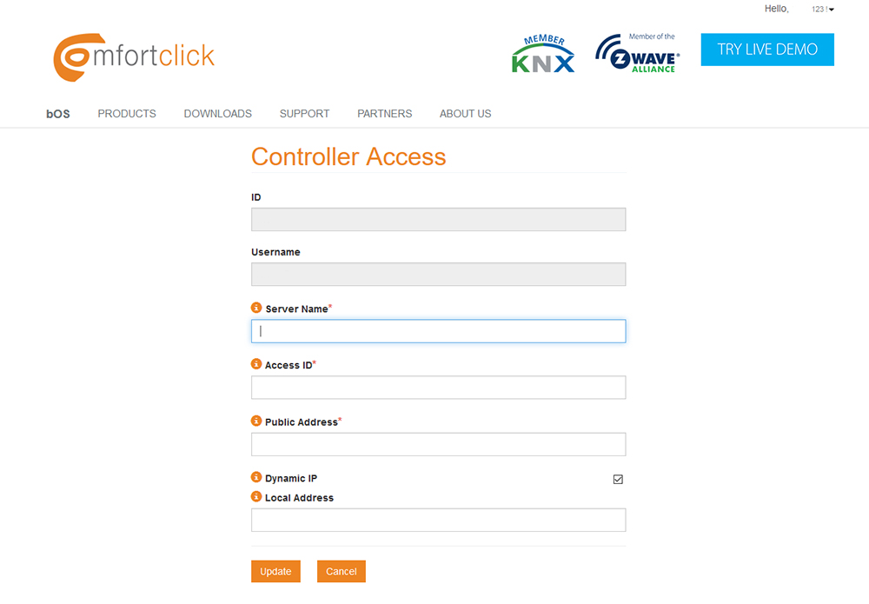
- Click Update when you’re done.

- Start creating your bOS configuration or open an existing configuration.

